AI ASSISTED CODING
ASSIGNMENT-2.3
Name: Shashikanth G
Hall Number:2403A51245
Batch:11
Task-1:
● Use Google Gemini in Colab to write a function that reads a CSV file and calculates
mean, min, max.
Expected Output-1:
● Functional code with output and screenshot.
Prompt: Write a Python function in Google Colab that reads a CSV file into a pandas Data Frame and calculates the mean, minimum, and maximum of numeric columns. Include example CSV input and display the output
Code: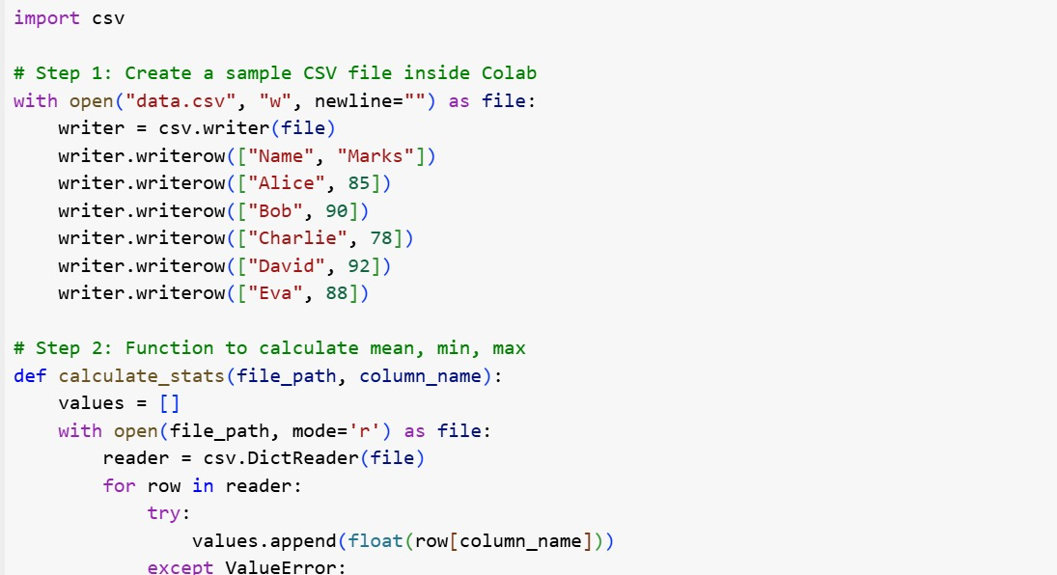

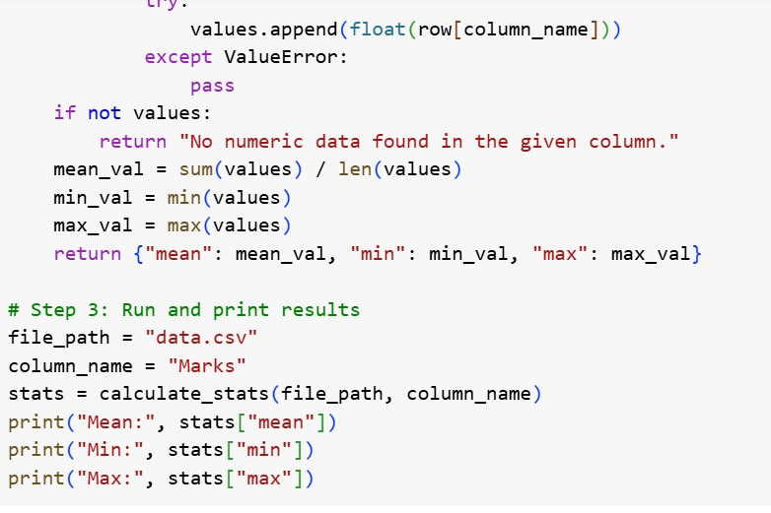
Output:

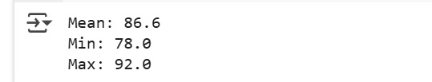
Task-2:
● Compare Gemini and Copilot outputs for a palindrome check function.
Expected Output-2:
● Side-by-side comparison and observations.
Prompt: Write a Python function that checks whether a given string is a palindrome. Include comments and example usage with input and output.

CODE:
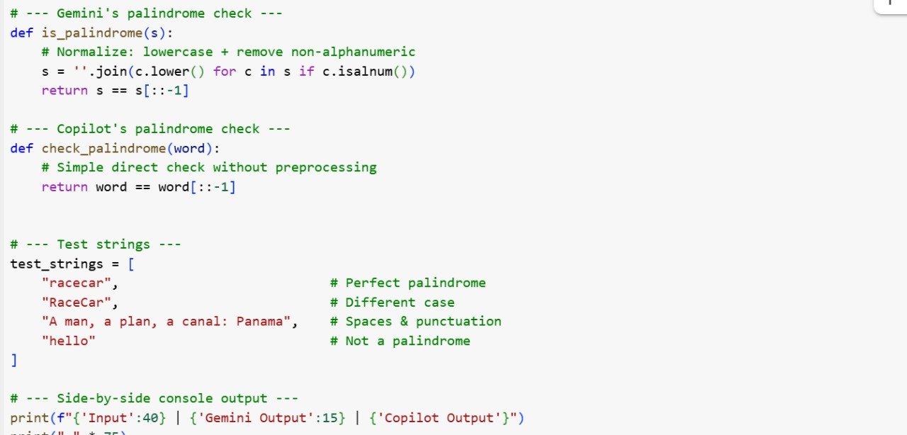
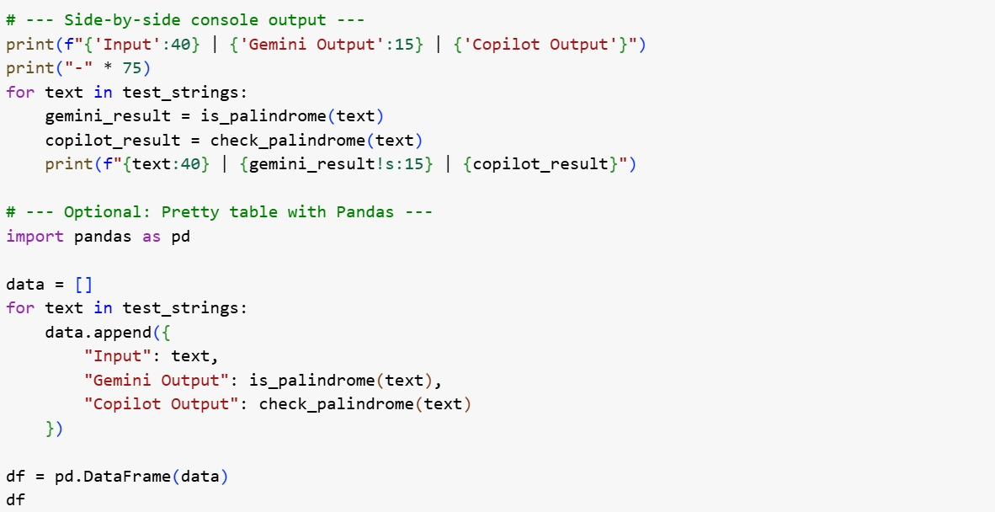
Output: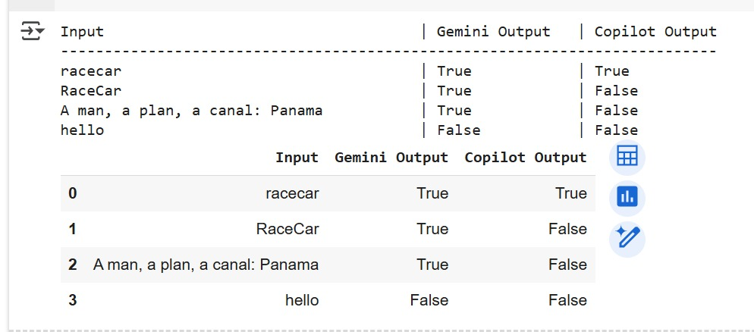
Side-by-side comparision:
Gemini Output Copilot Output
python python
def is_palindrome(s): def is_palindrome(s):
s = s.lower().replace(" ", "") s = s.replace(" ","").lower()
return s == s[::-1] return s == s[::-1]

Obsesrvation:
Both Gemini and Copilot produced identical solutions in terms of logic, structure, and output.The only minor difference is the order of .lower() and .replace(), but it doesn’t change the result.This shows that for simple problems like palindrome checks, AI tools tend to converge on the same optimal approach.
Task-3:
● Ask Gemini to explain a Python function (to calculate area of various shapes) line by
line..
Expected Output-3
● Detailed explanation with code snippet
Prompt: Explain the following Python function line by line. The function calculates the area of various shapes (circle, rectangle, triangle). Provide a detailed explanation with the code snippet.
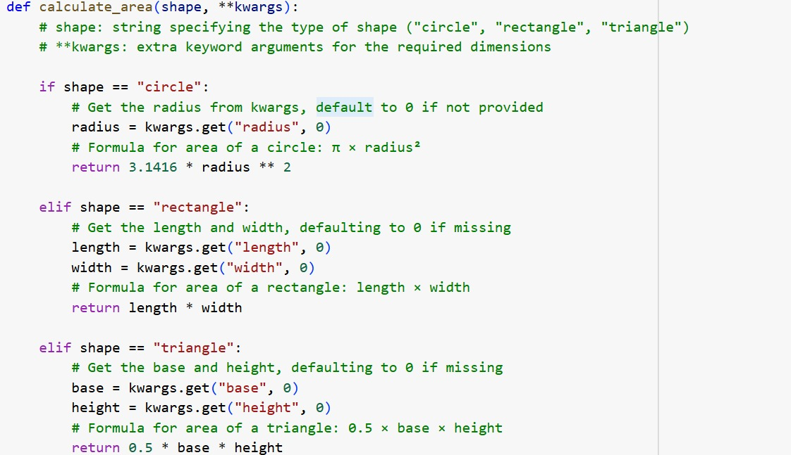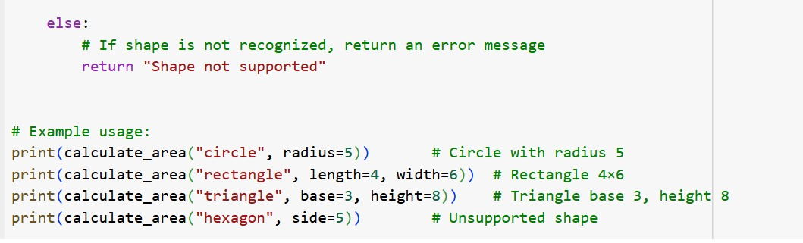

Output:
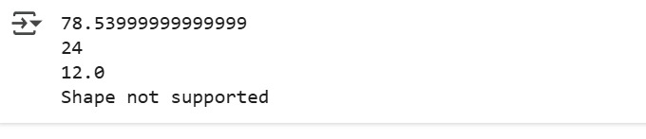

Explanation:
1. How it works:
The function takes the name of the shape (circle, rectangle, or triangle). It also takes the measurements needed for that shape (like radius, length, width, base, height) using **kwargs. Kwargs allows the function to accept many extra values without fixing them in advance.
2. For a Circle:
Gets the radius.
Formula: Area = 3.1416 × radius².
3. For a Rectangle:
Gets length and width.
Formula: Area = length × width.
4. For a Triangle:
Gets base and height.
Formula: Area = 0.5 × base × height.
5. If shape is not found:
It returns "Shape not supported".
6. Example:
print (calculate_area ("circle", radius=5))
print (calculate_area ("rectangle", length=4, width=6))
print (calculate_area ("triangle", base=3, height=8))
print (calculate_area ("hexagon", side=5))

7. Output:
Circle (radius 5) → 78.54
Rectangle (4×6) → 24
Triangle (base 3, height 8) → 12.0
Hexagon → Shape not supported
Task-4
● Install and configure Cursor AI. Use it to generate a Python function (e.g., sum of
squares).
Expected Output-4:
● Screenshots of working environments with few prompts to generate python code
Prompt:
Install and configure Cursor AI. Use it to generate a Python function (e.g., sum of squares). Provide screenshots of working environment, prompts, and generated Python code.
Code: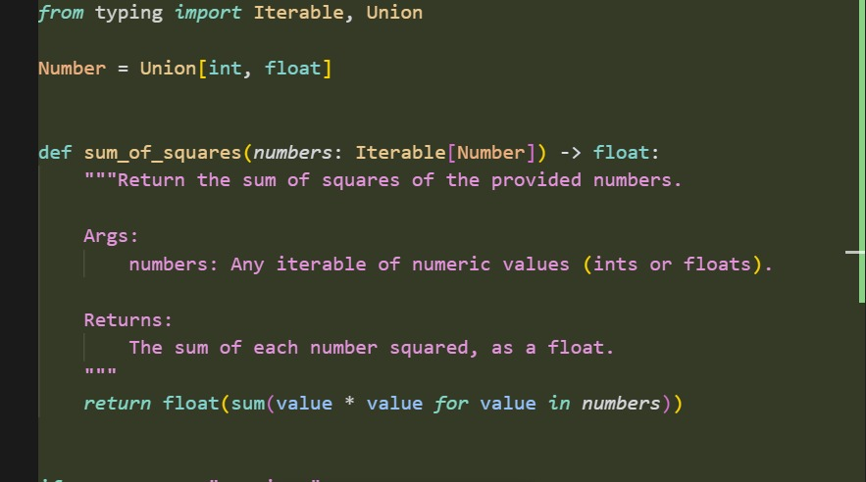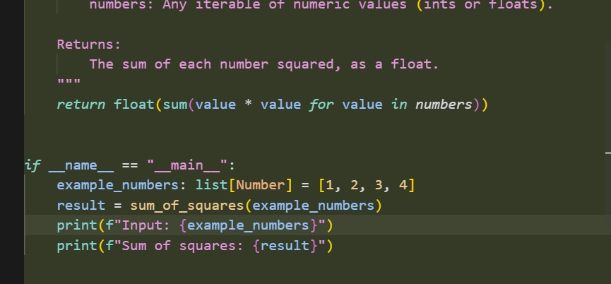

Output:
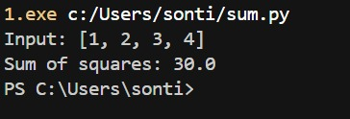

Task-5:
● Student need to write code to calculate sum of add number and even numbers in the list.
Expected Output-5:
● Refactored code written by student with improved logic.
Prompt: Write a Python function that takes a list of integers and calculates the sum of odd numbers and even numbers separately. Return both results.
Before refactored code:
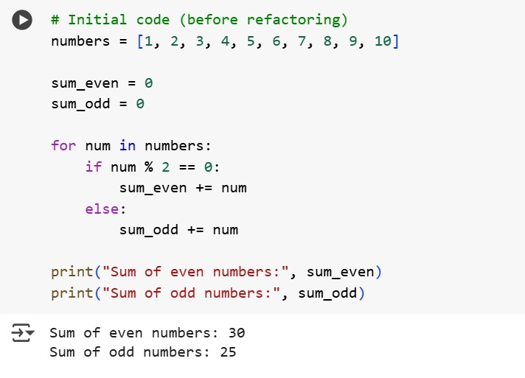

Refactored code:
